**A**

**Project Synopsis**

**BLACKHOLE**

**A Report Submitted**

In Fulfilment of the Requirement

for the Degree of

Bachelor of Technology - CSE

*Submitted by*

**STUDENT NAME : ROLL NO. :**

Janhvi Mishra 201910101110128

Abhaya Nigam 201910101110151

**Under Guidance of:** Ms. Arpita Vishwakarma

Faculty of Computer Science Department

Institute of Technology



**SHRI RAMSWAROOP MEMORIAL UNIVERSITY,**

**LUCKNOW-DEVA ROAD, U.P., INDIA**

**Session : 2022-2023**

**CERTIFICATE**

It is certified that the work contained in this project report titled “BLACKHOLE” by Janhvi Mishra and Abhaya Nigam has been carried out under my supervision and that this work has not been submitted elsewhere for any other degree.

**Ms. Arpita Vishwakarma**

**Assistant Professor**

**Computer Science and Engineering Department**

**Shri Ramswaroop Memorial University**

June, 2023

**Dr. Satya Bhushan Verma**

**Computer Science and Engineering Department**

**Shri Ramswaroop Memorial University**



**DECLARATION**

I, Janhvi Mishra (201910101110128) and Abhaya Nigam (201910101110151) student of Bachelor of Technology, Computer Science and Engineering department at Shri Ramswaroop Memorial University, Lucknow hereby declare that the work presented in this project titled **“ BLACKHOLE ”** is outcome of our own work, is bonafide, correct to the best of our knowledge and this work has been carried out taking care engineering ethics.

We have completely taken care in acknowledging the contribution of others in this academic work. We further declare that in case of any violation of intellectual property rights or copyrights found at any stage, I as the candidate will be solely responsible for the same.

DATE: Signature:

PLACE: Lucknow, UP Janhvi Mishra

(201910101110128)

Abhaya Nigam

(201910101110151)



ii

**ACKNOWLEDGEMENT**

The present work will remain incomplete unless we express our feeling of gratitude towards a number of persons who delightfully cooperated with us in the process of this work.

First of all I would like to thank my Mentor for her encouragement and support during the course of my study. I extend my hearty and sincere gratitude to my project guide, **Ms. Arpita Vishwakarma**  for her valuable direction, suggestions and exquisite guidance with enthusiastic encouragement ever since the commencement of this project.

This project would not have taken shape, without the guidance provided by project guide **Ms. Arpita Vishwakarma**  who helped in our project and resolved all the technical as well as other problems related to the project and, for always providing us with a helping hand whenever we faced any bottlenecks, in spite of being quite busy with their hectic schedules.

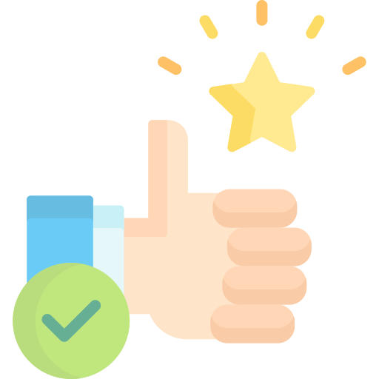

iii

**TABLE OF CONTENTS**

**CHAPTERS PAGE NO.**

CERTIFICATE………………………………………………………………………………i

DECLARATION…………………………………………………………………………….ii

ACKNOWLEDGEMENT…………………………………………………………………...iii

**CHAPTER 1: INTRODUCTION**

1.1 BlackHole………………………………………………………………………...1

1.2 PREFACE………………………………………………………………………..2

1.3 DEFINITION OF PROJECT TECHNOLOGY………………………………….3

**CHAPTER 2: REQUIREMENTS ANALYSIS AND FEASIBILITY STUDY**

2.1 REQUIREMENT ANALYSIS…………………………………………………...5

2.1.1 INFORMATION GATHERING…………………………………………...6

2.1.2 FUNCTIONAL REQUIREMENTS……………………………………….7

2.1.3 NON FUNCTIONAL REQUIREMENT………………………………….8

2.1.3.1 HARDWARE REQUIREMENTS…………………………………10

2.1.3.2 SOFTWARE REQUIREMENTS…………………………………..10

2.2 FEASIBILITY STUDY…………………………………………………………..11

2.2.1 TECHNICAL FEASIBILITY……………………………………………...11

2.2.2 OPERATIONAL FEASIBILITY…………………………………………..11

2.2.3 ECONOMICAL FEASIBILITY……………………………………………11

**CHAPTER 3: SYSTEM ANALYSIS AND DESIGN**

3.1 SYSTEM ANALYSIS……………………………………………………………..12

3.2 SYSTEM DESIGN………………………………………………………………...12

3.2.1 USE CASE DIAGRAM…………………………………………………….15

3.2.2 E-R DIAGRAM…………………………………………………………….16

3.2.3 DATA FLOW DIAGRAM………………………………………………….17

3.2.5 SNAPSHOTS……………………………………………………………….19

**CHAPTER 4: TESTING**

4.1 ABOUT THE TECHNOLOGY USED……………………………………………20

4.2 TESTING…………………………………………………………………………..21

4.2.1 UNIT TESTING……………………………………………………………..21

4.2.2 INTEGRATION TESTING………………………………………………….21

**CHAPTER 5: CONCLUSION AND SUGGESTIONS FOR FURTHER WORK**

5.1 CONCLUSION………………………………………………………………22

5.2 SUGGESTIONS FOR FURTHER WORK…………………………………23.

**REFERENCES……………………………………………………………………….24**

**…………………………………………………………………………………………………..**



**1. INTRODUCTION**

**1.1 BLACK HOLE**

Black Hole, a revolutionary music app that promises to provide a seamless and high-quality music streaming experience on your phone without the need for paid subscriptions or any intrusive advertisements. Blackhole - a music app designed to provide high-quality music streaming experience without any advertisements or paid subscriptions. If you are a fan of online music streaming, but have been struggling with low-quality apps or the hassle of downloading music from free online sites, then Black Hole might just be the perfect solution for you. Are you tired of using music apps with low quality or having to pay a premium subscription fee to access high-quality music? Have you tried downloading songs from free online music sites, only to be faced with the hassle of navigating through countless ads and pop-ups?

Black Hole is here to change the game. With our app, you can enjoy high-resolution music streaming directly on your phone, ensuring that you have access to the highest quality audio without having to pay a dime. We know how frustrating it can be to have your music experience interrupted by ads, which is why we've made sure that our app is completely ad-free, giving you an uninterrupted and immersive listening experience.

But that's not all. With Blackhole, you can also download songs directly onto your device, making it easy for you to listen to your favourite tracks even when you're offline. And if you want to expand your music library, you can use our app to convert and download YouTube videos to audio, giving you access to a vast selection of music from across the internet.

Overall, Blackhole is an app that aims to provide a seamless and high-quality music experience to users who value quality and convenience. So if you're looking for a music app that offers high-quality streaming, hassle-free downloads, and an ad-free environment, look no further than Black Hole.



1

**1.2 PREFACE**

Music is an integral part of our lives, and with the rise of online music streaming, it has become easier than ever to access our favourite songs and artists. However, with so many music apps available, it can be challenging to find one that provides a high-quality streaming experience without any intrusive ads or the need for a paid subscription. Moreover, downloading music from free online music sites can often be a frustrating and time-consuming process.

This is where Black Hole comes in. The team behind Black Hole has recognized the need for a music app that prioritises high-quality streaming and hassle-free downloads, all without any advertisements or paid subscriptions. With the Black Hole app, users can enjoy an immersive and uninterrupted music streaming experience that rivals even the most expensive music apps on the market.

In this project, we will explore the various features of the Black Hole app, including its high-resolution music streaming capabilities and its ability to download songs directly onto your device. We will also delve into the app's unique feature of converting and downloading YouTube videos to audio, expanding your music library like never before.

Through this project, we hope to showcase how Blackhole has transformed the music streaming industry, providing users with a high-quality, seamless, and hassle-free experience that is unmatched by other apps. So whether you're a music enthusiast looking for the ultimate streaming experience or simply someone who wants to listen to their favourite songs without interruptions, Black Hole is the app for you.

2

**1.3 DEFINITION OF PROJECT TECHNOLOGY**

**Flutter:**

Flutter is a mobile application development framework created by Google. It allows developers to build high-quality, natively compiled applications for mobile, web, and desktop from a single codebase. Flutter uses the Dart programming language, which is designed to provide a fast development cycle with a rich set of pre-built widgets, tools, and libraries that help developers build beautiful and responsive user interfaces.

Flutter provides a modern and efficient development environment that allows developers to easily create complex user interfaces and animations. It provides a rich set of pre-built widgets, including Material Design and Cupertino widgets, that allow developers to build beautiful and responsive UIs for both Android and iOS platforms. Flutter also includes a powerful toolset for building animations and transitions, which can be used to create engaging and immersive user experiences.

**Hive Database:**

Hive is a lightweight and fast NoSQL database solution for Flutter and Dart. It provides a simple and easy-to-use interface to store and retrieve key-value pairs, making it a great choice for small to medium-sized mobile applications.

Hive stores data on the local device's file system, rather than using a traditional SQLite database or a server-based database. This means that Hive provides fast read and write operations, as well as offline support. Hive also has a small footprint, making it suitable for mobile apps with limited resources.

Hive uses a simple data model based on boxes and key-value pairs. Boxes are like tables in a traditional database, while key-value pairs are like rows and columns. To store data, you create a box and then insert key-value pairs into it. Hive supports a wide range of data types, including integers, doubles, booleans, strings, and lists.

Hive also provides several advanced features, including the ability to define custom type adapters, which allows you to serialize and deserialize complex objects. It also provides support for reactive programming with Streams, making it easy to build reactive UIs with Flutter.

In summary, Hive is a fast, lightweight, and easy-to-use NoSQL database solution for Flutter and Dart, which is suitable for small to medium-sized mobile applications.

**API :**

API stands for Application Programming Interface. It is a set of protocols, routines, and tools that software developers use to build software applications. An API specifies how software components should interact with each other, and it provides a way for different applications to communicate with each other.

An API defines the functionality and methods that are available to other software applications or systems. This means

that developers can use an API to access data or services from a remote system or to integrate different software systems. APIs can be used for a variety of purposes, including data sharing, functionality integration, and workflow automation.

3

APIs are typically defined using a standardized description format, such as OpenAPI or Swagger. This allows developers to understand the structure and behavior of the API and to build software applications that can interact with it. APIs can be accessed using a variety of protocols, including REST, SOAP, and GraphQL.

In summary, an API is a set of protocols, routines, and tools that developers use to build software applications that can communicate and interact with other software systems or services. APIs allow developers to access data and services from remote systems or to integrate different software systems into a unified workflow.

**Git & GitHub :**

Git is a distributed version control system that is widely used for source code management. It allows developers to track changes in their code, collaborate with others, and maintain different versions of their codebase. GitHub is a cloud-based platform that provides hosting for Git repositories. It provides tools for collaboration, issue tracking, and code review, making it an essential tool for modern software development.

Git provides a powerful toolset for managing source code and collaborating with others. It allows developers to track changes in their code, create branches and merge changes, and maintain different versions of their codebase. GitHub provides a cloud-based platform for hosting Git repositories, which makes it easy for developers to collaborate with others and contribute to open-source projects.

**OAuth:**

OAuth is an open standard protocol that allows users to grant third-party applications access to their resources, without giving them their password or other sensitive credentials. OAuth is widely used by social media platforms, cloud services, and other online services to provide secure and controlled access to their APIs.

OAuth provides a standardized way for users to grant permission to third-party applications to access their resources, such as photos, contacts, or messages, stored on a service provider's server. It does this by enabling users to authenticate themselves with the service provider, and then authorizing the application to access their resources on their behalf.

OAuth uses access tokens to provide secure and controlled access to the user's resources. When a user grants permission to an application, the service provider issues an access token to the application, which can be used to access the user's resources for a limited period of time. The access token can be revoked by the user at any time, giving them control over the access to their resources.

OAuth also supports different levels of access control, allowing users to grant or revoke different permissions to different applications. For example, a user may grant an application read-only access to their photos, but not allow it to post new photos on their behalf.

In summary, OAuth is an open standard protocol that enables secure and controlled access to a user's resources on a service provider's server by third-party applications, without requiring the user to share their sensitive credentials. OAuth provides a standardized way for users to grant and revoke permissions to applications and uses access tokens to provide secure and controlled access to the user's resources.

4

**2. REQUIREMENTS ANALYSIS AND FEASIBILITY STUDY**

**2.1 REQUIREMENTS ANALYSIS**

The requirementis any function, constraint, or property that the system must provide, meet or satisfy in order to fulfil its purpose.

1. User Registration and Login:

* Users should be able to create an account and login using their email or social media accounts.
* Implement secure authentication and password recovery mechanisms.

1. User Profile:

* Users should have a profile where they can view and update their personal information.
* Include options to set profile pictures and manage preferences.

1. Music Streaming:

* Provide a seamless and high-quality music streaming experience.
* Integrate APIs or libraries for audio playback with support for various audio formats.
* Implement features like play, pause, skip, shuffle, and repeat.

1. Search and Browse:

* Include a search functionality to allow users to find songs, albums, artists, or playlists.
* Implement filters and sorting options to refine search results.
* Enable browsing by genres, top charts, popular artists, etc.

1. Ad-Free Experience:

* Ensure the app is completely ad-free, providing uninterrupted music streaming.
* Implement a mechanism to block any unwanted advertisements.

1. Offline Mode:

* Allow users to download songs and albums for offline listening.
* Implement a download manager to handle downloads efficiently.
* Provide options to manage downloaded music and remove them if needed.

1. YouTube Conversion and Download:

* Integrate APIs or libraries to convert and download YouTube videos as audio files.
* Implement a user-friendly interface for entering YouTube URLs and initiating conversions.

1. Music Library Management:

* Provide options for users to create and manage playlists.
* Implement features like adding, removing, and reordering songs in playlists.
* Include options to favorite or like songs, albums, or artists.

1. Social Sharing:

* Enable users to share their favorite songs, playlists, or their profile on social media platforms.
* Implement social media integration for seamless sharing.

5

1. User Feedback and Ratings:

* Include a feedback mechanism where users can provide suggestions, report issues, or rate the app.
* Implement a user-friendly interface for submitting feedback.

1. User Notifications:

* Send notifications to users regarding new releases, recommended songs, or updates.
* Allow users to customize their notification preferences.

1. User Settings:

* Provide settings options for customizing the app experience, such as audio quality settings, theme selection, language preferences, etc.

1. Security and Privacy:

* Implement secure data storage and transmission protocols.
* Ensure user data and preferences are protected.
* Comply with privacy regulations and guidelines.

1. Platform Compatibility:

* Develop the app using Flutter framework for cross-platform compatibility.
* Ensure the app functions smoothly on both iOS and Android devices.

1. Performance Optimization:

* Optimize the app for efficient memory and battery usage.
* Implement caching mechanisms to reduce data consumption and improve performance.

1. Analytics and Reporting:

* Integrate analytics tools to gather insights about user behavior, popular songs, etc.
* Generate reports to analyze app performance, user engagement, and other metrics.

1. App Updates and Maintenance:

* Plan for regular app updates to introduce new features, fix bugs, and enhance security.
* Ensure compatibility with future OS versions and device updates.

**2.1.1 INFORMATION GATHERING**

1. Target Audience:

* Identify the target audience for the app, such as music enthusiasts, casual listeners, specific age groups, or regions.
* Determine their preferences, expectations, and needs regarding music streaming apps.

1. Competitor Analysis:

* Research existing music streaming apps and analyze their features, strengths, and weaknesses.
* Identify what sets Black Hole apart from competitors and how it can provide a better user experience.

1. Audio Quality Requirements:

* Determine the desired audio quality for streaming and downloading songs.
* Consider the supported audio formats and bitrates to ensure high-quality playback.

6

1. Licensing and Copyright:

* Understand the legal aspects related to streaming and downloading music from various sources.
* Research licensing requirements and explore partnerships with music labels or streaming platforms.

1. User Feedback and Pain Points:

* Gather feedback from potential users or existing users of other music streaming apps.
* Identify common pain points, challenges, and desired features expressed by users.

1. Offline Listening Usage:

* Determine the importance of offline listening for the target audience.
* Understand how users would like to manage and organize their downloaded music.

1. YouTube Conversion and Download:

* Assess the popularity and demand for downloading music from YouTube.
* Gather insights into user expectations regarding the YouTube conversion and download feature.

1. App Monetization Strategy:

* Determine the intended revenue model for the app, such as in-app purchases, premium subscriptions, or ads (if any).
* Explore alternative monetization options, such as partnerships, sponsored content, or exclusive features.

1. Preferred Languages and Localization:

* Identify the target regions and languages for localization.
* Determine if the app should support multiple languages or localization features.

1. Security and Privacy Considerations:

* Define the necessary security measures to protect user data and prevent unauthorized access.
* Comply with privacy regulations, such as GDPR or CCPA, to ensure user data privacy.

**2.1.2 FUNCTIONAL REQUIREMENTS**

**User Registration and Authentication:**

Allow users to create accounts and sign in securely.

Provide options for social media login (e.g., Google, Facebook) or email/password authentication.

**Music Streaming:**

Enable users to search and stream music from a vast catalog.

Provide high-quality audio streaming with support for various audio formats.

Implement features like play, pause, skip, shuffle, and repeat.

**Ad-Free Experience:**

Ensure that the app is completely ad-free, offering users an uninterrupted music streaming experience.

**Offline Music Playback:**

Allow users to download songs for offline playback.

Provide a user-friendly interface to manage downloaded songs and playlists.

Implement features like automatic synchronization of offline content when online.

7

**YouTube Conversion and Download:**

Enable users to convert and download YouTube videos as audio files.

Implement a seamless process to convert and download YouTube videos within the app.

**Music Library Management:**

Provide options for users to create and manage playlists.

Implement features like favoriting songs, creating custom playlists, and organizing music library.

**Search and Discover:**

Implement a robust search functionality to allow users to find songs, albums, artists, or genres.

Provide recommendations and personalized music suggestions based on user preferences and listening history.

**Social Sharing:**

Allow users to share songs, playlists, or their music activity on social media platforms.

Implement integration with popular social media APIs for seamless sharing.

**Audio Controls and Notifications:**

Provide controls for audio playback in the notification shade and lock screen.

Support audio control features such as play, pause, skip, and volume control from the notification shade or lock screen.

**User Settings and Preferences:**

Allow users to customize app settings, such as audio quality, theme, and notification preferences.

Provide options for language selection, equalizer settings, and other user preferences.

**Cross-Platform Compatibility:**

Ensure the app is compatible with both Android and iOS platforms, adhering to platform-specific guidelines and standards.

**Error Handling and Reporting:**

Implement proper error handling mechanisms to inform users about any issues and provide meaningful error messages.

Incorporate crash reporting tools to track and fix app crashes or errors.

**App Updates and Notifications:**

Notify users about app updates and new features.

Implement in-app notifications or push notifications to inform users about important announcements or changes.

**2.1.3 NON FUNCTIONAL REQUIREMENTS**

1. Performance:

* The app should provide fast and responsive user interactions, ensuring smooth scrolling, searching, and playback.
* Minimize loading times for songs, playlists, and other content.
* Optimize the app for efficient memory and battery usage to provide a seamless user experience.

8

1. User Interface and User Experience:

* Design an intuitive and user-friendly interface that is easy to navigate and understand.
* Ensure consistent branding, theming, and visual appeal throughout the app.
* Implement smooth transitions and animations to enhance the user experience.

1. Compatibility and Responsiveness:

* Ensure the app is compatible with a wide range of devices, screen sizes, and resolutions.
* Adapt the app layout and design to different screen orientations (portrait and landscape).
* Test the app on various devices and OS versions to ensure responsiveness and compatibility.

1. Security:

* Implement robust security measures to protect user data, including login credentials and personal information.
* Encrypt sensitive data transmission between the app and backend servers.
* Regularly update and patch security vulnerabilities to ensure the app's security.

1. Accessibility:

* Design the app with accessibility features in mind to cater to users with visual, hearing, or motor impairments.
* Ensure compatibility with screen readers and provide alternative text for images and buttons.
* Incorporate font size adjustments, color contrast options, and other accessibility features.

1. Scalability and Performance under Load:

* Design the app to handle a large number of concurrent users without performance degradation.
* Implement server-side optimizations to handle increased traffic and streaming requests.
* Perform load testing to ensure the app can handle peak usage scenarios.

1. Offline Functionality:

* Ensure the offline mode of the app works reliably and allows users to access their downloaded music seamlessly.
* Implement synchronization mechanisms to update offline content when the device is back online.

1. Data Storage and Management:

* Efficiently manage local storage to store downloaded songs and user preferences without consuming excessive device storage.
* Implement data caching strategies to reduce the need for frequent network requests and improve performance.

1. Error Handling and Logging:

* Implement robust error handling mechanisms to handle network connectivity issues, server errors, and other potential failures gracefully.
* Log relevant error and debugging information to assist in troubleshooting and future app improvements.

1. App Updates and Maintenance:

* Plan for regular app updates to introduce new features, fix bugs, and enhance performance.
* Implement an efficient update mechanism to deliver updates to users seamlessly.

9

**2.1.3.1 HARDWARE REQUIREMENTS**

**Development Machine:**

* A computer capable of running the chosen development environment and IDE smoothly.
* Minimum requirements typically include a multi-core processor, sufficient RAM, and ample storage space for development tools and resources.

**Target Devices:**

* Android: Ensure compatibility with a range of Android devices, including smartphones and tablets, with various screen sizes and resolutions. Consider compatibility with different Android versions.
* iOS: Ensure compatibility with iPhone and iPad devices, considering different screen sizes and iOS versions.

**Network Connectivity:**

* The app requires a stable internet connection for music streaming and downloading songs from YouTube.
* Optimize the app to handle variable network conditions, such as low bandwidth or intermittent connectivity.

**2.1.2.2 SOFTWARE REQUIREMENTS**

**Development Environment:**

* Flutter SDK (compatible with the desired Flutter version)
* Dart programming language
* Integrated Development Environment (IDE) such as Visual Studio Code, Android Studio, or IntelliJ IDEA with Flutter and Dart plugins.

**Operating System Compatibility:**

* Windows (7 or later)
* macOS (10.12 or later)
* Linux (any distribution that supports Flutter)

**Backend and APIs:**

* Design and develop backend infrastructure to support user management, authentication, and data storage.
* Integrate with APIs or libraries for music streaming, audio playback, and YouTube conversion.
* Utilize database technologies for storing user preferences, downloaded songs, and other relevant data.

**Libraries and Dependencies:**

* Utilize appropriate libraries for audio streaming, caching, and offline playback.
* Integrate libraries for network requests, JSON parsing, and data management.
* Use dependency management tools like Pub or Flutter packages for managing external dependencies.

10

**2.2 FEASIBILITY STUDY**

**2.2.1 TECHNICAL FEASIBILITY**

* The Blackhole app is developed using the Flutter framework, which is a popular cross-platform development framework supported by Google. Flutter allows for building high-quality, native-like applications for both Android and iOS platforms.
* The technical infrastructure required for music streaming and downloading is readily available, including audio codecs, streaming protocols, and storage capabilities on mobile devices.
* The integration of YouTube video conversion and download feature may require utilizing appropriate APIs and ensuring compliance with the platform's terms of service.

**2.2.2 OPERATIONAL FEASIBILITY**

* The Blackhole app's user interface and functionalities should be designed to be user-friendly, intuitive, and easily navigable.
* Regular updates and maintenance should be planned to address bugs, introduce new features, and ensure compatibility with the latest operating systems and devices

**2.2.2 ECONOMIC FEASIBILITY**

* The Blackhole app aims to provide a high-resolution music streaming experience without paid subscriptions or advertisements. To sustain the app's development, alternative revenue streams such as in-app purchases, premium features, or partnerships could be explored.
* Market research and analysis should be conducted to evaluate the potential user base and demand for a music app with these features. This information will help determine if the app can generate sufficient revenue to cover development and maintenance costs.

11

**3. SYSTEM ANALYSIS AND DESIGN**

**3.1 SYSTEM ANALYSIS**

System analysis involves examining the functional and technical aspects of the app, identifying the requirements, constraints, and dependencies. It helps in understanding the overall architecture and design of the system to ensure a successful implementation of the app.

**User Roles and Authentication:**

* Identify the different user roles, such as regular users and administrators.
* Determine the authentication and authorization mechanisms required for each user role.

**User Interface Design:**

* Design an intuitive and user-friendly interface that allows easy navigation and access to app features.
* Consider the placement of buttons, menus, and controls to ensure a seamless user experience.

**Music Streaming and Playback:**

* Analyze the technical requirements for high-quality music streaming, including audio codecs and streaming protocols.
* Ensure smooth and uninterrupted music playback, taking into account network conditions and potential buffering issues.

**Offline Music Management:**

* Define the mechanisms for downloading and storing songs on the user's device for offline playback.
* Determine the file formats and storage options that can be supported for offline music storage.

**YouTube Conversion and Download:**

* Analyze the technical requirements and limitations for converting and downloading YouTube videos as audio files.
* Consider the APIs or services that can be integrated to enable seamless YouTube conversion and download.

**Data Storage and Management:**

* Determine the data storage requirements, such as user profiles, playlists, downloaded songs, and preferences.
* Choose appropriate databases or storage solutions to efficiently manage and retrieve the required data.
* Search and Recommendation Engine:

**3.2 SYSTEM DESIGN**

System design involves planning the architecture, components, and interactions required to build the Black Hole music app. It includes determining the technical implementation details, selecting appropriate tools and technologies, and defining the system's overall structure and behavior.

12

**User Interface:**

* Design an intuitive and visually appealing user interface that provides easy navigation and access to app features.
* Implement screens for music playback, search, playlists, offline mode, and YouTube conversion.
* Ensure consistent design elements, typography, and color schemes throughout the app.

**Authentication and User Management:**

* Implement user authentication mechanisms, such as email/password login or social media login options.
* Provide user registration and account management functionalities.
* Store user profiles securely, including personal information, preferences, and playlists.

**Music Streaming and Playback:**

* Implement a music player with controls for play, pause, skip, repeat, and shuffle.
* Integrate streaming protocols, such as HTTP Live Streaming (HLS) or DASH, to ensure high-quality audio playback.
* Handle buffering, network interruptions, and seamless transitioning between tracks.

**Offline Music Management:**

* Develop a mechanism for downloading and storing songs on the user's device for offline playback.
* Allow users to manage their downloaded songs, including organizing them into playlists and deleting them when needed.
* Implement a local music library to store metadata and track information for offline tracks.

**YouTube Conversion and Download:**

* Integrate YouTube APIs or services to enable conversion and download of YouTube videos as audio files.
* Implement a mechanism to extract audio from YouTube videos and store them in the app's library or device storage.
* Ensure compliance with YouTube's terms of service and API usage guidelines.

**Data Storage and Management:**

* Choose an appropriate database or storage solution to store user profiles, playlists, downloaded songs, and metadata.
* Implement efficient data retrieval and caching mechanisms to enhance performance.
* Ensure data security and backup strategies to prevent data loss.

**Search and Recommendation Engine:**

* Develop a search feature that allows users to find songs, albums, artists, and genres based on keywords or filters.
* Implement a recommendation engine that suggests personalized music based on user preferences, listening history, and popular trends.

**Social Media Integration:**

* Integrate social media sharing capabilities to allow users to share their favorite songs, playlists, or activities on platforms like Facebook, Twitter, or Instagram.
* Implement APIs or SDKs provided by social media platforms for seamless integration and authentication.

13

**Error Handling and Logging:**

* Implement error handling mechanisms to display meaningful error messages to users in case of failures or exceptions.
* Integrate logging mechanisms to track system events, errors, and user activities for debugging and troubleshooting purposes.

**Performance and Scalability:**

* Optimize the app's performance to ensure smooth music streaming and responsiveness.
* Consider techniques like lazy loading, caching, and background processing to enhance user experience.
* Design the system to handle a large number of concurrent users and scale the infrastructure as needed.

**Security and Privacy:**

* Implement secure communication protocols (HTTPS) to protect user data during transmission.
* Encrypt sensitive data stored on the server or device, such as user passwords or personal information.
* Implement appropriate access controls and authorization mechanisms to protect user data and prevent unauthorized access.

**Testing and Quality Assurance:**

* Conduct comprehensive testing, including unit testing, integration testing, and user acceptance testing.
* Perform testing for different device types, screen sizes, and OS versions to ensure compatibility.
* Continuously monitor and optimize the app's performance, security, and user experience.

14

**3.2.1 USE CASE DIAGRAM**

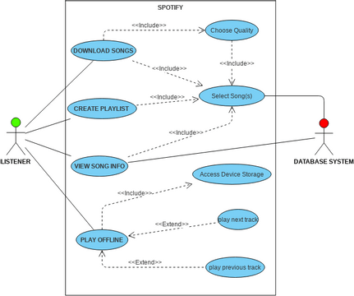

Stream Music: Users can stream high-quality music through the app, providing a seamless and immersive listening experience.

Download Songs: Users can download songs directly to their devices, allowing them to enjoy their favorite tracks even when offline.

Search and Browse: Users can search for songs, artists, or albums, and browse through recommendations to discover new music.

Manage Downloaded Songs: Users can manage their downloaded songs, including organizing them into playlists or deleting unwanted files.

Share Music on Social Media: Users can share their favorite music on various social media platforms, allowing them to connect and engage with others.

15

**3.2.2 E-R DIAGRAM**

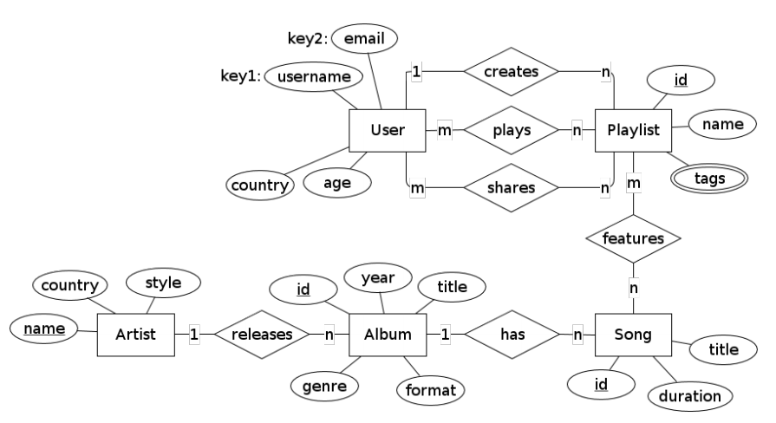

Entities:

User: Represents a user of the Blackhole app. It has attributes such as user_id, username, email, and password.

Song: Represents a song available in the app. It has attributes such as song_id, title, artist, duration, genre, and file_path (the path to the audio file).

Playlist: Represents a user's playlist. It has attributes such as playlist_id and name.

Relationships:

The User entity has a one-to-many relationship with the Playlist entity, as a user can have multiple playlists, but a playlist belongs to a single user.

The Song entity can be associated with the Playlist entity through a many-to-many relationship. This relationship is not explicitly shown in the ER diagram, but it can be represented by an additional table connecting the Song and Playlist entities.

16

**3.2.3 DATA FLOW DIAGRAM**

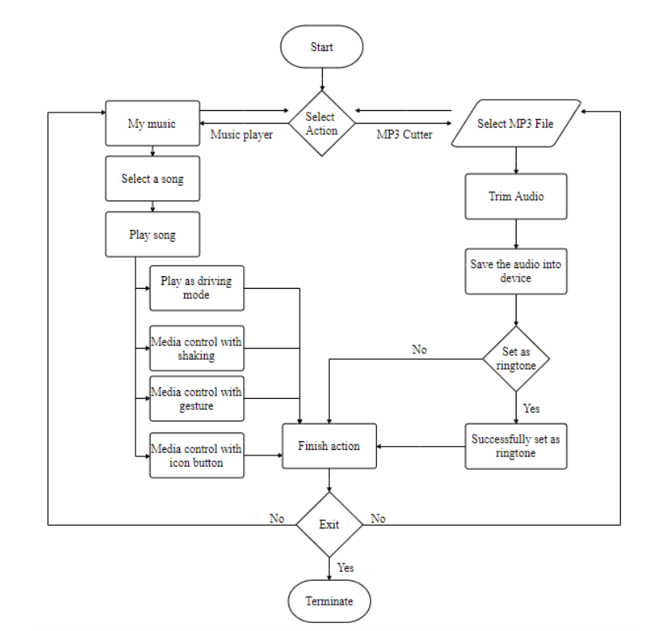

Components:

* User: Represents the user of the Blackhole app. They can register or log in to access the app's features.
* Blackhole Music App: The main component of the app that provides the high-resolution music streaming experience and allows users to download songs. It interacts with other components to manage user requests and provide the requested functionality.
* Server: Represents the backend server that handles the logic and data management of the Blackhole app. It processes user requests, retrieves songs from the database, and sends the requested data back to the app.

17

* Song Database: Stores the information about songs available in the app, including song titles, artists, durations, genres, and file paths. The Blackhole app interacts with the song database to fetch song data for streaming and downloading.

Data Flow:

* Register/Login: Data flows from the User component to the Blackhole Music App component when a user registers or logs into the app
* Streaming/Download Requests: Data flows from the Blackhole Music App component to the Server component when a user requests to stream or download a song
* Song Data: Data flows from the Song Database to the Server component when the server needs to retrieve song information for streaming or downloading.
* Streamed/Downloaded Song: Data flows from the Server component to the Blackhole Music App component when the requested song is streamed or downloaded.

18

**3.2.4 SNAPSHOTS**

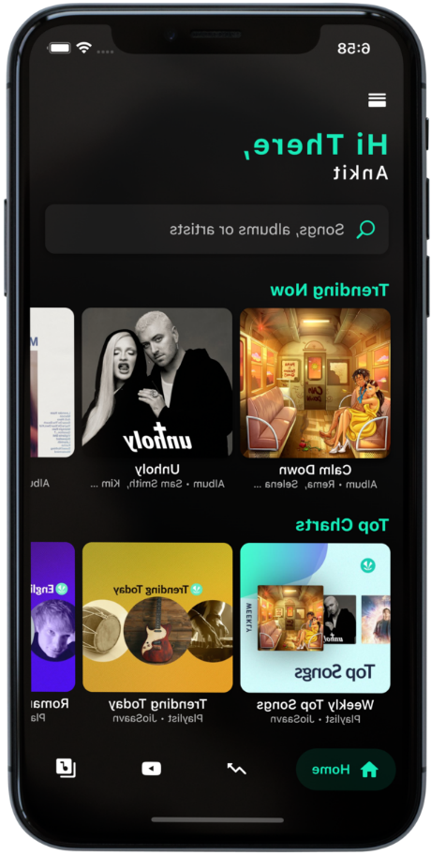 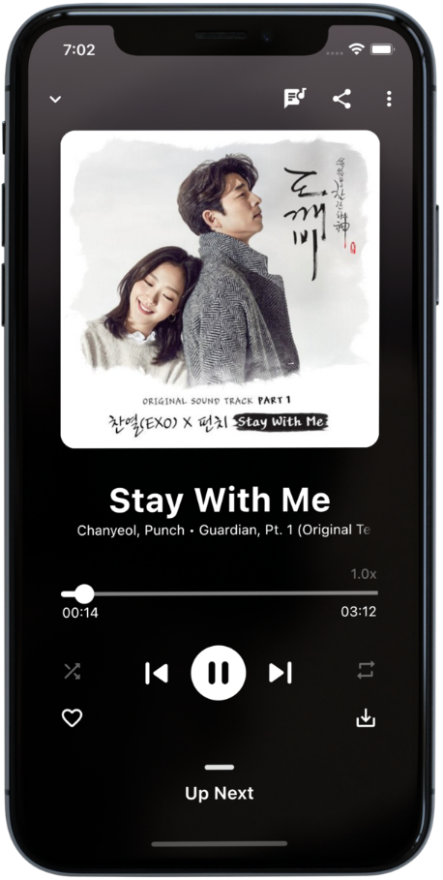 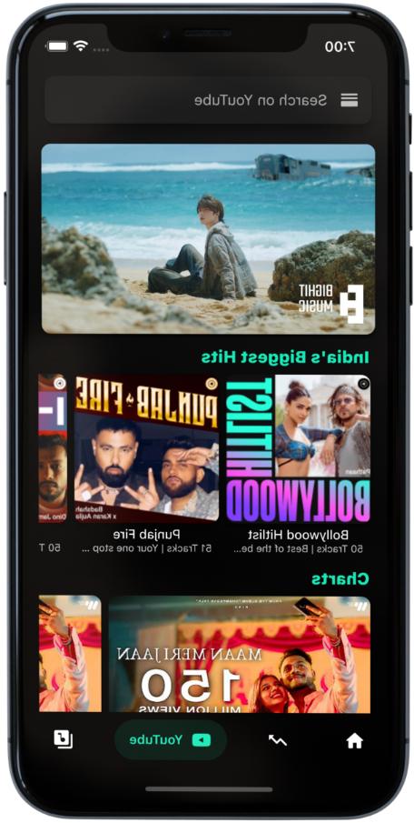

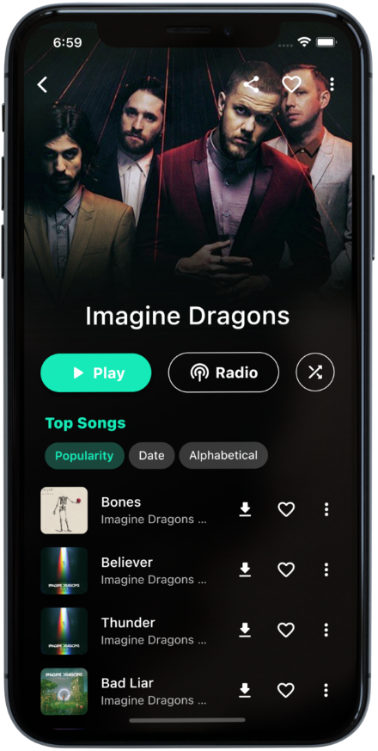 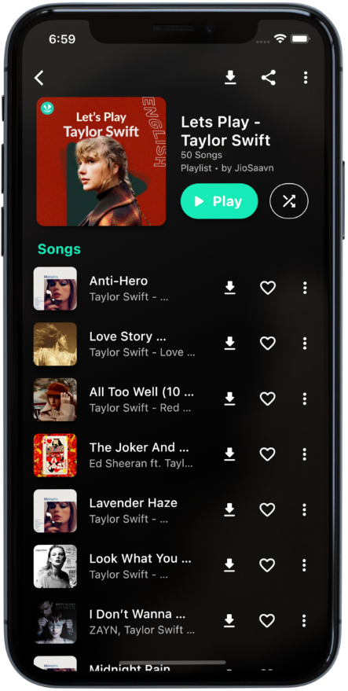 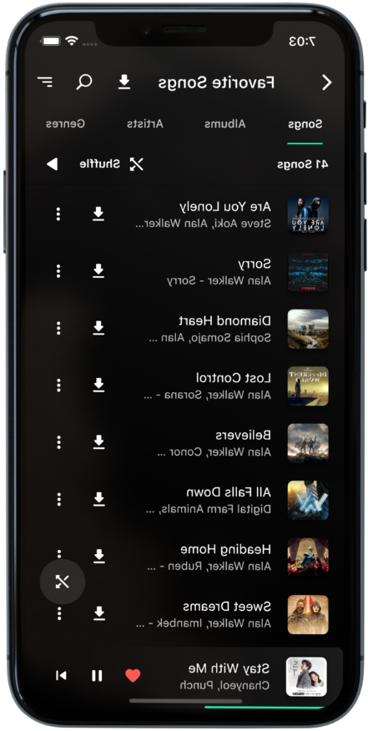

19

**4.** **TESTING**

**4.1 ABOUT THE TECHNOLOGY USED**

The Blackhole music app is built using the Flutter framework, which is a popular cross-platform development framework created by Google. Flutter allows developers to write code once and deploy it on multiple platforms, including Android and iOS.

Here are some of the technologies used in building the Blackhole music app:

**Flutter:** The app is developed using the Flutter framework, which provides a rich set of tools and libraries for building beautiful and performant user interfaces.

**Dart:** Flutter uses the Dart programming language for writing the app's logic. Dart is a modern, object-oriented language with features like hot-reloading, which enables faster development and testing cycles.

**Audio Streaming:** To ensure high-quality music streaming, the app leverages audio streaming technologies. This may involve using libraries or APIs that handle the streaming of audio data over the network and decoding it for playback.

**Offline Downloading:** The app enables users to download songs onto their devices for offline listening. This functionality may involve technologies like file management, caching, and storage to efficiently download and store the songs on the user's device.

**API Integration:** The app may integrate with various APIs to access music catalogs, retrieve song information, and handle user authentication and registration. These APIs could include services like YouTube for converting and downloading videos to audio or music streaming platforms for accessing a wide range of songs.

**Database Management:** The app may use a database system to store and manage information about songs, user profiles, and preferences. This could involve technologies like SQLite or Firebase for efficient data storage and retrieval.

**Ad-Free Experience:** The app ensures an ad-free experience by not displaying any intrusive advertisements. This may involve implementing features to block or exclude ads from being displayed within the app's user interface.

20

**4.2 TESTING**

When it comes to testing the Blackhole music app, various technologies and methodologies can be employed to ensure its quality and reliability.

**4.2.1 UNIT TESTING**

Unit testing is performed to test individual components or units of code in isolation. In the context of the Blackhole app, unit tests can be written to verify the functionality of specific modules or features, such as audio streaming, downloading songs, or API integrations. Tools like Flutter's built-in testing framework, flutter_test, can be used for writing and executing unit tests.

**4.2.2 INTEGRATION TESTING**

Integration testing focuses on testing the interactions and integration between different components or modules of the app. For example, integration tests can be conducted to ensure smooth communication between the app and external APIs for song conversion or streaming. Flutter provides the integration_test package, which enables developers to write integration tests that simulate user interactions and verify the behavior of the app as a whole.

21

**5. CONCLUSION AND SUGGESTIONS FOR FURTHER WORK**

**5.1 CONCLUSION**

In conclusion, the Black Hole music app has revolutionised the online music streaming industry by providing users with a high-quality streaming experience without the need for paid subscriptions or intrusive advertisements. The app's high-resolution streaming capabilities and its ability to download songs directly onto your device make it an excellent choice for anyone who values convenience and quality.

One of the most unique features of Black Hole is its ability to convert and download YouTube videos to audio, which allows users to expand their music library like never before. This feature sets Blackhole apart from other music apps and gives users access to a vast selection of music from across the internet.

With Blackhole, music lovers can enjoy an immersive and uninterrupted listening experience that rivals even the most expensive music apps on the market. The app's commitment to high-quality streaming and hassle-free downloads has made it a favourite among users who value convenience, quality, and affordability.

Overall, the Black Hole music app is a game-changer in the online music streaming industry, providing users with a high-quality, seamless, and hassle-free experience that is unmatched by other apps. So whether you're a music enthusiast looking for the ultimate streaming experience or simply someone who wants to listen to their favourite songs without interruptions, Black Hole is the app for you. Try it out today and discover a new way to enjoy music!



22

**5.2 SUGGESTIONS FOR FURTHER WORK**

The Black Hole music app has already made significant strides in providing users with a high-quality music streaming experience without the need for paid subscriptions or intrusive advertisements. However, there is always room for improvement, and the app's developers are constantly exploring new features and updates to enhance the user experience.

One area that the developers are currently exploring is the integration of social media features into the app. This would allow users to share their favourite songs and playlists with friends and followers, expanding the app's reach and creating a more connected music community.

Another feature that the developers are exploring is the ability to create custom playlists based on a user's listening history and preferences. This would allow for a more personalised listening experience, and users could discover new songs and artists that they may not have otherwise found.

The Black Hole team is also exploring the possibility of adding a feature that allows users to stream live music events directly through the app. This would provide users with access to exclusive live performances from their favourite artists and bands, creating a more immersive music experience.

Finally, the Black Hole team is committed to improving the app's existing features, such as the high-resolution music streaming and seamless downloads, to ensure that users continue to have the best possible experience.

In conclusion, the future of Black Hole is bright, and the app's developers are constantly working to improve and enhance the user experience. With exciting new features and updates on the horizon, the Black Hole music app is sure to continue providing users with a high-quality, seamless, and hassle-free music streaming experience.

23

**REFERENCES**

* <https://www.geeksforgeeks.org/>
* <https://flutter.dev/>
* <https://www.w3schools.com/>
* <https://spring.io/>
* <https://www.rover.com/blog/dog-adoption-guide/>
* <https://www.pawslikeme.com/dog-adoption-guide/>
* <https://dribbble.com/tags/flutter>
* <https://github.com/abhayanigam/flutter_projects_and_practice>
* <https://in.pinterest.com/>
* <https://developer.spotify.com/documentation/web-api>

24